**Módulo 1, Sábado 4.**

**Questions for practice**

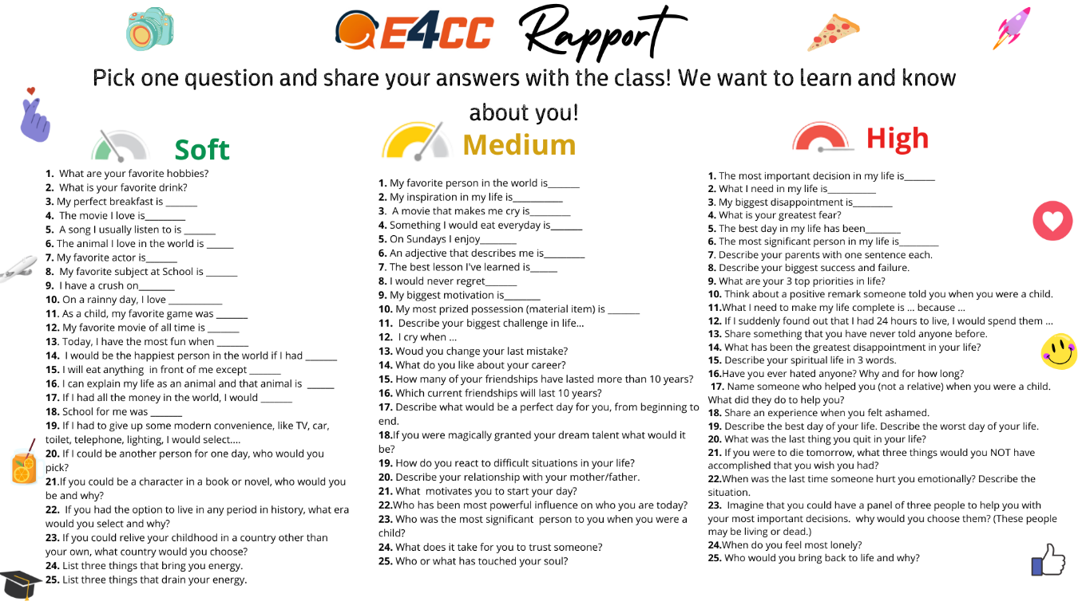

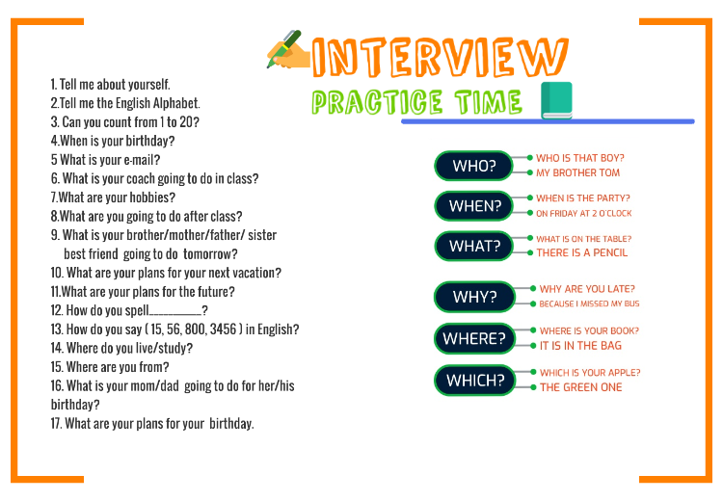

**Conversation in call center.**

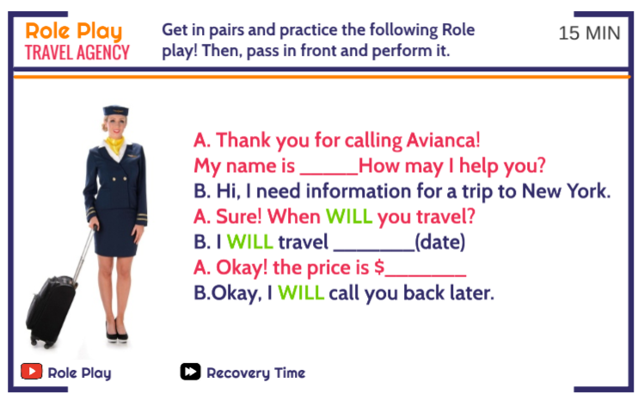

**Future using will**

Positive = I will work

Neggative: I will not work or I won’t work.

Question: Am I will work?

**What are your plans for the future?**

1. Graduate from university
2. Start my own company
3. Learn another language
4. Get a master degree
5. Be my own boss
6. Have my own house
7. Invest my money

**Wh questions**

What (Que) = What will you eat

Where (Donde) = Where will I with your family?

When (Cuándo) = When will You go to England?

Why (Porqué) = Why will She come back her parents?

Who/With (Con quién) = Who will drink He in the restaurant?

Examples what:

What will they cut in the garden?

What will we buy the new car?

What will I spend my money?

Examples where:

Where will I in the vacations?

Where will she eat with your friends?

Where will he use the favorite shirt?

Examples when:

When will we arrive your parents?

When will he buy his house?

When will she cut the flowers?

Examples Why:

Why will they study in the university?

Why will I buy my new car?

Why will you check my homework?

Examples Who/with

Who will I visit the museum with?

Who will You run in the challenge with?

Who will he play videogames with?

**Future going to structure affirmative**

Pepita is going to draw a flower.

He is going to read a horror book.

**Future going to structure negative**

The dog is not going to follow the motorcycle.

The wolf is not going to run and bark.

**Future going to structure questions (interrogative)**

Is Maria going to eat pupusas?

Is He going to understand the English class?

**This, that, these, those**

This/ singular and close to me

That/ singular and far to me

These/ plural and close to me

Those/ plural and far to me

Sentences with This

This is my car

This is my pencil

This is my girlfriend

Sentences with That

That is my puppy

Sentences with These

Sentences with Those

**Link in words**

FirstHe is going to play baseball in the stadium.

Then He is going to dance cumbia for two hours.

Later He is going to jump with his dog.

More later He is going to read a book in the room

After this He is going to see the sky.

Finally, He is going to cry.

**Questions in future**

What is he going to dance?

Why is he going to cry in the park?

What book is he going to read?

**Other wh questions**

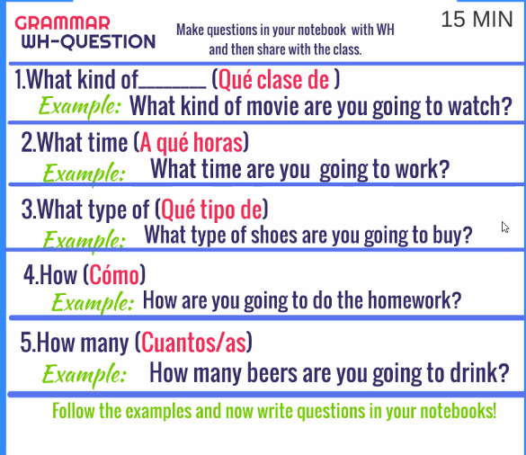

What kind of music will you listen?

I will listen to romantic music.

What kind of food will you eat tomorrow?

I will eat Mexican food.

What will you eat?

I will eat

What time will you do the homework?

I will do the homework at 8:00 am.

What time will you buy shoes?

I will buy shoes at 8:00 pm

How will she cook?

She will cook perfect.

Firs she will buy the ingredients.

Second prepare chicken, then she will go to the supermarket.

How many books will you read?

I will read two books.

How much money will you win?

I will win one hundred dollars.

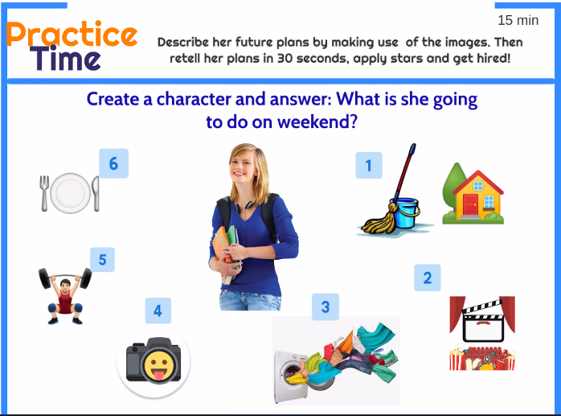

She is Susana this weekend she is going to have a party at home,

first she is going to clean the house

then she is going to prepare a movie…

later she is going prepare the sweet

in the afternoon she is going to take a shower and have exercise.

finally, she will to prepare table to have dinner with your friends.

Conversation:

1. Hi welcome, what kind of drinks are you have today?
2. With pleasure, we will have Lemonade, hot drinks, and soda.
3. I will need two sodas.
4. Ok, right.
5. What time prepare the drinks?
6. We will prepare the drinks at 3 minutes.

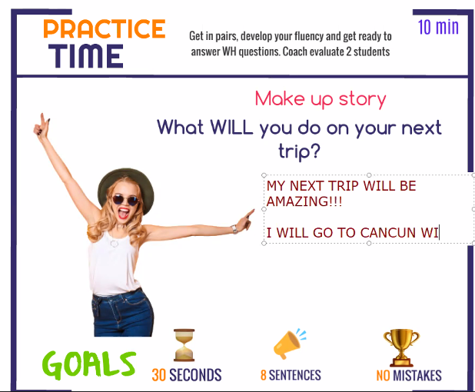

My next trip will be amazing!!!

I will go to Cancun with my girlfriend

We will swim in the beach; we will drink a lot of mojitos.

Later, we are going to meet with my parents.

Then My girlfriend and my going to visit the rest of restaurants.

Finally, we will drive a car at my cabin.

**Sentences with going to**

She is going to have dinner at 7 pm at a restaurant.

He is going to take a shower at 6:00 am and he is going to enjoy.

He is going to watch a movie with your family and friends.

They are not going to read a book with his sister.

She is going to dance romantic music at 8:00 pm with her boyfriend

Will you drink Coca Cola?

They are Pablito and Shila.

They are a couple.

First, they are going to fly New York to a concert

Then they will swim in the beach of California

To continue they will get married in the restaurant.

Besides that, they are going to dance with their friends

Finally, they will sleep on the hotel California.